CRC CARD

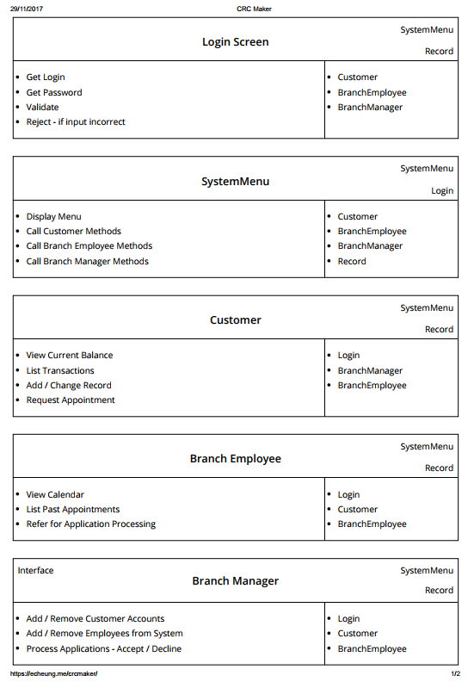

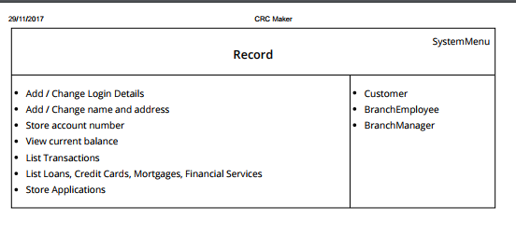

1attmp

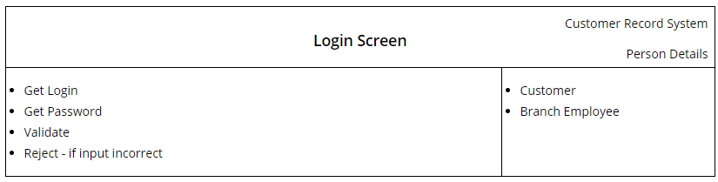

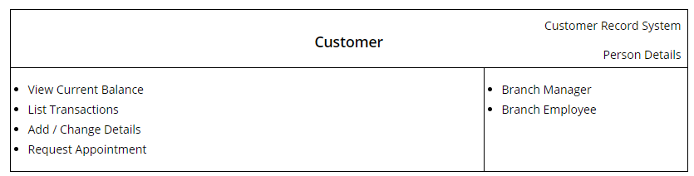

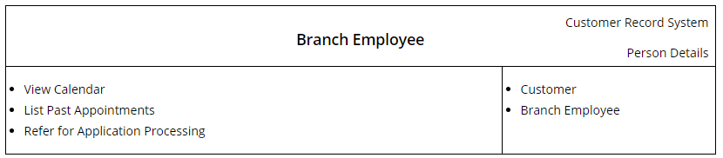

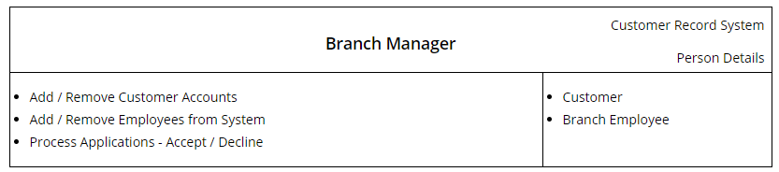

<https://echeung.me/crcmaker/>

[

{

"name": "Login Screen",

"superclasses": "Customer Record System",

"subclasses": "Person Details ",

"type": 1,

"responsibilities": [

"Get Login ",

"Get Password ",

"Validate ",

"Reject - if input incorrect"

],

"collaborators": [

"Customer",

"Branch Employee"

]

},

{

"name": "Menu",

"superclasses": "Customer Record System",

"subclasses": "",

"type": 1,

"responsibilities": [

"Get Balance",

"Get Transactions",

"Get Calendar",

"Get Person Details",

"Get Appointments",

"Set Person Details",

"Set Appointment "

],

"collaborators": [

"Login Screen",

"Customer ",

"Branch Employee",

"Branch Manager"

]

},

{

"name": "Customer",

"superclasses": "Customer Record System",

"subclasses": "Person Details ",

"type": 1,

"responsibilities": [

"View Current Balance",

"List Transactions",

"Add / Change Details",

"Request Appointment "

],

"collaborators": [

"Branch Manager",

"Branch Employee"

]

},

{

"name": "Branch Employee",

"superclasses": "Customer Record System",

"subclasses": "Person Details",

"type": 1,

"responsibilities": [

"View Calendar ",

"List Past Appointments",

"Refer for Application Processing"

],

"collaborators": [

"Customer ",

"Branch Employee"

]

},

{

"name": "Branch Manager",

"superclasses": "Customer Record System ",

"subclasses": "Person Details ",

"type": 1,

"responsibilities": [

"Add / Remove Customer Accounts",

"Add / Remove Employees from System",

"Process Applications - Accept / Decline",

""

],

"collaborators": [

"Customer",

"Branch Employee"

]

}

]